Midterm Project

Janahan Thanabalasinkam

500975108

ITM 200

Toronto Metropolitan University

Nashid Anjum

April 13th, 2023

**Introduction**

In this project, we were given the task to read a csv file (excel). This was a new topic for us, and we were assigned with the task for reading the file on PyCharm, calculating total sales for each year, estimating the sales for 2022 (last 6 months) and finally graphing our finding in both a vertical/horizontal graph. We were also told to print our findings onto a separate txt file named stats which I renamed into carStats.

Github Link: <https://github.com/Janahant/Automotive-sales-statistics.git>

**Problem 1 Code**

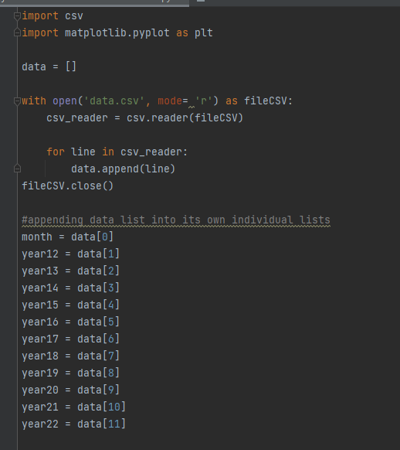

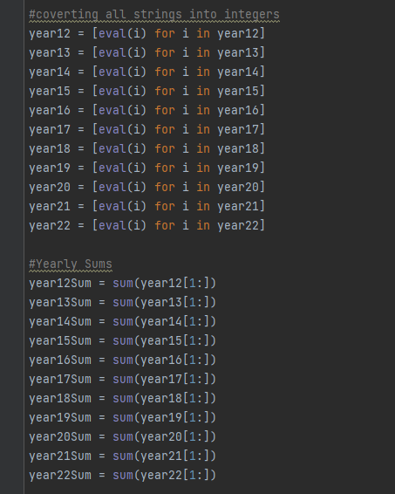

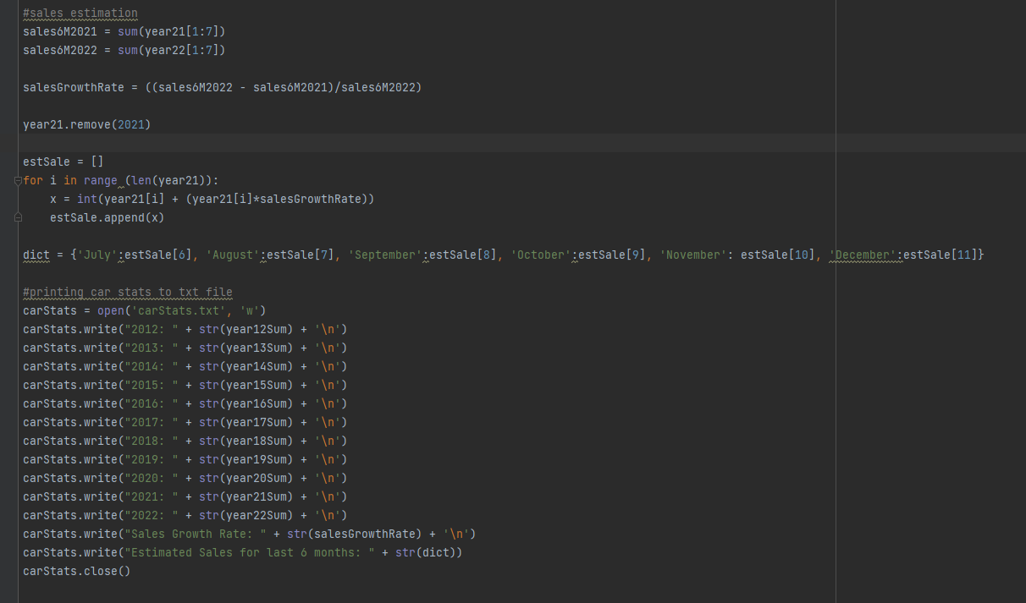

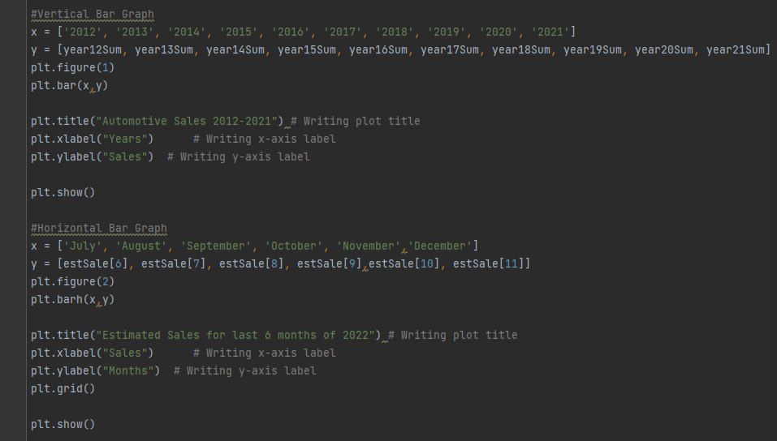

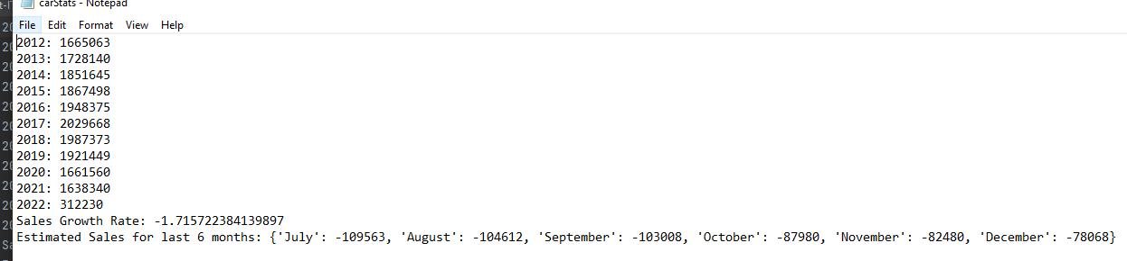**Problem 1 Output**

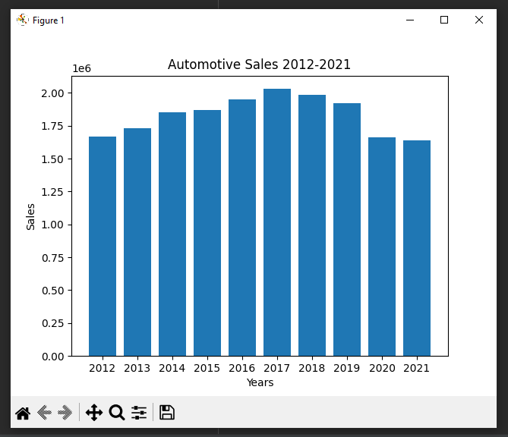

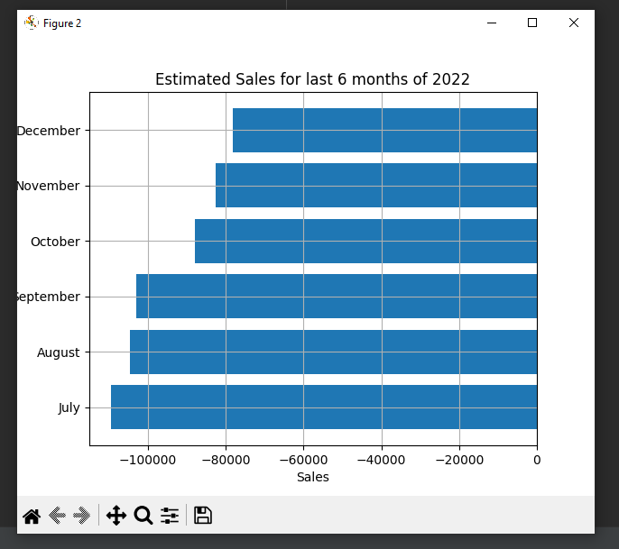

**Conclusion:**

Overall, I found this assignment to be very education. It taught me how to graph and read csv files successfully to plot data. This is an extremely important skill to have for me as I want to pursue a job in data analysis in the future. The areas where I experienced difficulties in this assignment were regarding the downloading of matplotlib and graphing the data. In conclusion, I found this assignment to be extremely useful and I was able to use the skills I’ve learned all semester to do so.